Finansportalen Insurance calculators -Administration panel

**Contents**

**Overview** 1

**How to use** 1

Companies 2

WS Status 3

WS Poster 5

# **Overview**

The purpose of the self service is to allow the insurance companies to manage their test environment configuration and see their web service endpoint status. The Self service is available in the insurance administration application in Finansportalen’s test environment (<https://test.finansportalen.no/insurance-calculator-admin/disp/admin>).

# **How to use**

Log into the insurance calculator administration application in test, using the same credentials as for Finansportalen’s “Datafanger” in test. If you lack username and password, please write to [youtrack@fportalen.no](mailto:youtrack@fportalen.no)

In the tab "*Companies*" you can manage your company’s configuration, in the tab "*WS Status*" you can see your WS endpoint status and in "*WS Poster*" tab is possible to check company`s web service endpoint.

## Companies

In the tab "*Companies*" (Figure 2) you can manage your company’s configuration.

Companies table has action buttons below (Figure 1):

* Edit selected row
* Reload Grid



Figure 1 – button panel

By pressing the "**Edit selected row**" button you will land in "**Edit screen**". By pressing "**Reload Grid**" button you will refresh the table (Figure 2).

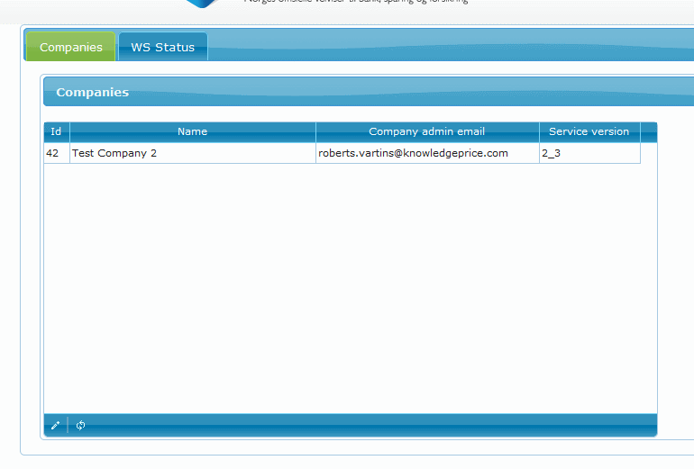

Figure 2 – company table

In "**Edit screen**" you can update the configuration (Figure 3).

**Be aware, that all changes become active after one minute**

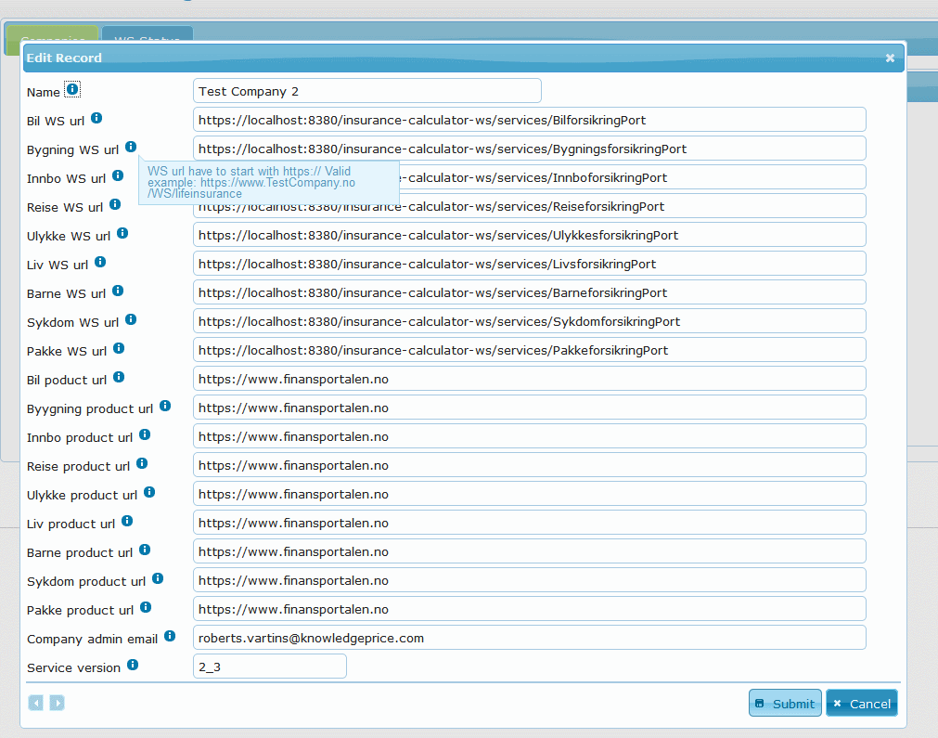

Figure 3 – company edit screen

## WS Status

In the "WS Status" tab you can see your company’s web service status (*Figure 4*) (see explanation below columns). Columns:

* Company – name;
* Lob – line of business (i.e., product);
* Company active – administrator can disable your company’s configuration, this column shows whether it is active or not
* WS status – five status values
  + ping true – the WS is available
  + ping false – the WS is not available (WS has returned false)
  + ping false (notification sent) – if the WS has returned false or ping operation has failed more than two times then company is notified
  + ping failure – the WS is not available (ping operation has failed)
  + ping failure (notification sent) – if the WS has returned false or ping operation has failed more than two times, then the company is notified
* Last success – last time when ping operation succeeded
* Last failed – last time when ping operation failed
* Entire uptime (%) – the ratio between failed ping requests and all ping requests
* Details – by clicking on link you will see the details: last ping error details
* Execute ping – manually perform ping operation

**Note: By default, the ping operation is executed every 15 minutes automatically**

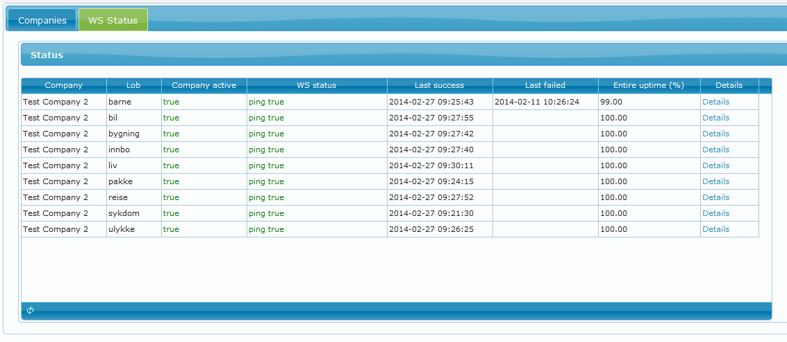

Figure 4 – web services status

## WS Poster

For verification purposes in the "WS Poster" tab (Figure 5) is possible to make a POST request from the application towards company`s web services.

* WS endpoint – company web service endpoint url;
* WS operation – request type;
  + Ping – connection testing request
  + Get price – get a real data from WS
* Request – SOAP request content.

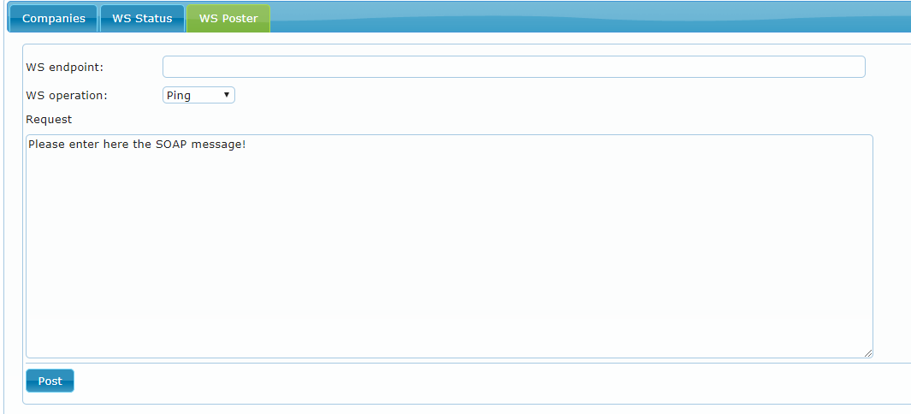

Figure 5 – WS Poster tab view